CSC 4120/6120 INTRODUCTION TO ROBOTICS

### MODULE 5

### All source codes for GoPiGo 3 robot are available in the GitHub page: <https://github.com/DexterInd/GoPiGo3>

The Distance and Servo Sensor needs to be properly configured for these exercises which has been covered in Module 2.

Distance:

<https://www.dexterindustries.com/GoPiGo/get-started-with-the-gopigo3-raspberry-pi-robot/4-attach-the-camera-and-distance-sensor-to-the-raspberry-pi-robot/>

Servo:

<https://www.dexterindustries.com/GoPiGo/get-started-with-the-gopigo3-raspberry-pi-robot/6-attach-the-servo-kit-gopigo3-raspberry-pi-robot/>

**Raspbian for Robots**

If you switch to “Raspbian for Robots” OS, you need need to download/upload module 5 scripts to the Pi and work on below exercises. It is good to connect battery pack for power while running these exercises since we will be moving the robo around for object detection and avoidance.

Follow below to get “Raspbian for Robots”:

<https://docs.google.com/document/d/1jgToT5YenshgOQhQj6ujSerVt1WlupMrtxTzdRjEIM4/edit?usp=sharing>

Once the Pi is on and ready, go to the link below on your browser:

1. <http://dex.local>
2. Select VNC
3. Open a Terminal
4. **Download the exercise files:**

git clone <https://github.com/yash-bhat/Module-5.git>

cd Module-5

1. Now you have all the scripts for Module 5. Go through each exercise and run the scripts.

### **Object Avoidance**

Distance sensor required + Servo needs to be properly configured. It is ideal to place the distance in alignment with the servo as shown below so that we can have full viewing angle during servo rotation.

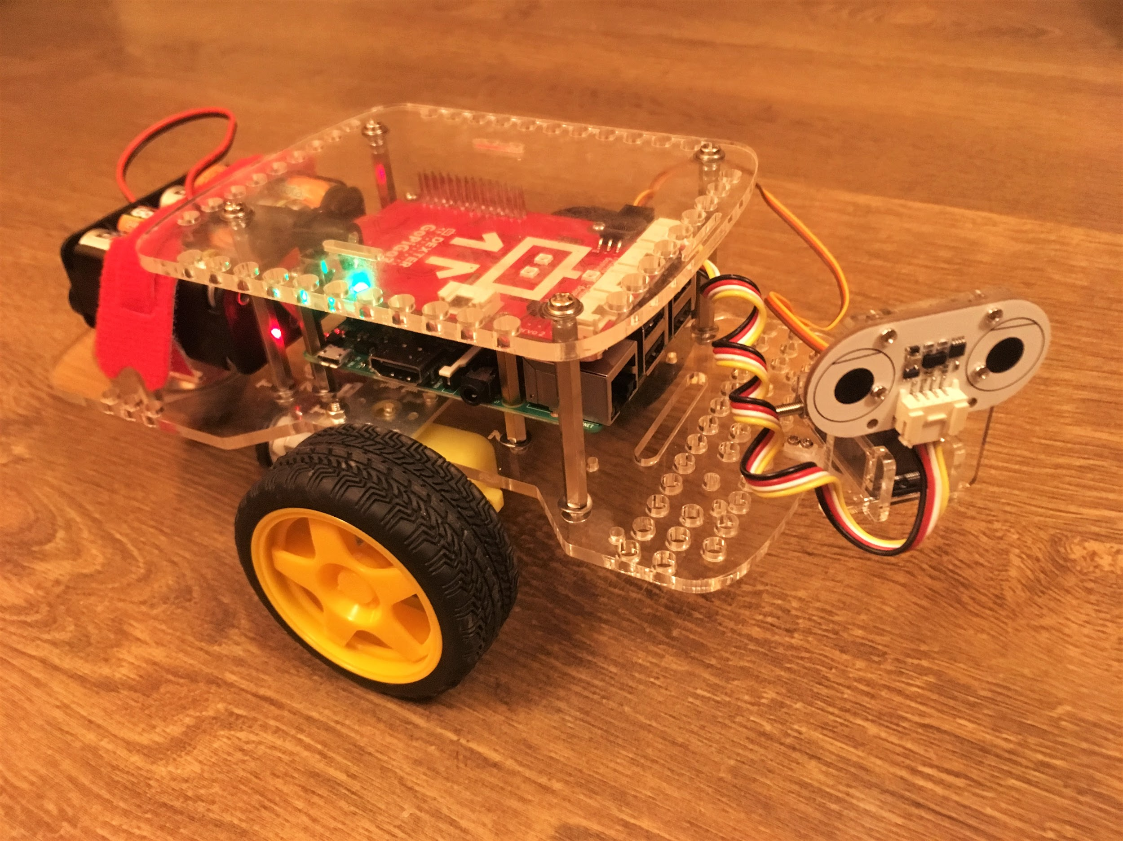

**Exercise 1**: **IntelligentObjectAvoider**

In this exercise we will see how to avoid objects as the robot moves.

On the Terminal, type:

#### cd GoPiGo3-Projects/IntelligentObjectAvoider

#### python3 robot.py

**Raspbian:**(from Module 5 folder)

#### cd Exercise1

#### python3 robot.py

Result:

The robot should be able to avoid objects and move away. You can create a little(with enough space for viewing angle of the sensors and robot movement) maze and check if robot successfully steers away and traverses in desired way.

Refer Module 5, Exercise 1 for video on this exercise.

**Exercise 2**: **ObjectAvoidanceRobot**

In this exercise we will see how the robot should detect an object or an obstacle and come to a complete halt. Once the object is eliminated or moved away, it should continue along the path.

On the Terminal, type:

#### cd GoPiGo3-Projects/ObjectAvoidanceRobot

#### python3 object_avoidance_robot.py

**Raspbian:**(from Module 5 folder)

#### cd Exercise1

#### python3 object_avoidance_robot.py

Result:

Place an object with a reasonable distance and check if robot detects and halts. After a few seconds remove the object and see if the robot moves now.

Refer Module 5, Exercise 2 for video on this exercise.

**Assignment Problems for Demonstration**

**1.**

1. **Use the codes from Exercise 1 and identify the best cases (situations where it is suitable to use this application) and corner cases (situations where the functionality will not work). You have to identify through experimental testing. The robot must be put in such a situation and must demonstrate the best or corner cases. Demonstrate 2 BEST and 2 CORNER cases during the demo day and you must discuss how you will try to resolve the 2 CORNER cases.**
2. **Repeat 1(a) for Exercise 2.**

**Bonus points (5x):** Five points EACH for resolving (finding a solution, implementing and demonstrating) EACH corner case.

-----------------------------------------------------------------------------------------------------------------------------